U.S. AbilityOne Commission

Report to the President

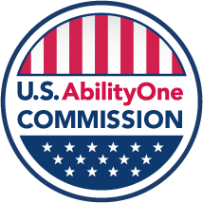

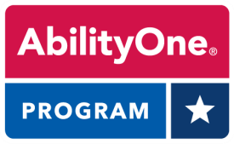

March 28, 2024
★  

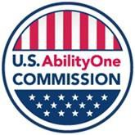

President Joseph R. Biden, Jr. March 28, 2024
The White House
1600 Pennsylvania Ave, NW Washington, DC 20500

Dear Mr. President,

On behalf of the U.S. AbilityOne Commission, I am pleased to submit this report on the progress and achievements of the Commission and the AbilityOne Program it oversees.
What is now the U.S. AbilityOne Commission was established in June 1938 when President Franklin D. Roosevelt signed the Wagner-O’Day Act to promote the purchase of products made by blind workers. Its mission expanded in 1971 when President Nixon signed legislation sponsored by Senator Jacob K. Javits to expand the Program to include people with significant disabilities and to allow for the provision of services as well as products. Thanks to landmark legislation, unprecedented technological advancement, and societal changes over the last half century, the United States has made enormous advances in ensuring opportunities for people who are blind or have significant disabilities.
The AbilityOne Commission recognized the opportunity to better support these underserved communities and better meet the needs of Federal agencies through modernization of the AbilityOne Program with its FY 2022-2026 Strategic Plan. The Commission considers that plan a series of important promises to its stakeholders. This report outlines key areas where it has kept, or is on track to keep, these promises.
Significant accomplishments include: ending use of subminimum wage certificates throughout the Program; identifying and proposing necessary legislative changes to provide more good jobs to people who are blind or have significant disabilities; continuing implementation of recommendations from the statutory “Panel on DoD and AbilityOne Contracting Oversight, Accountability, and Integrity” (898 Panel); making major improvements in effective stewardship; introducing limited competition between nonprofit agencies on the highest dollar contracts, while protecting the mission objectives of the Program; updating compliance policies to provide a more streamlined and effective oversight and inspection system of the nonprofit agencies; and beginning an IT modernization effort. Central to all of these initiatives are active listening, increasing transparency, and public engagement.
In the year ahead, the Commission will develop next-generation cooperative agreements with the Central Nonprofit Agencies that lay out roles and responsibilities within the Program.
We greatly appreciate your support and investment in the Commission as we work to enhance and expand opportunities for people who are blind or have significant disabilities.
Sincerely,

Jeffrey A. Koses
Chair and Presidential Appointee

Contents
Transforming the AbilityOne Program: Current Successes and Future Initiatives 1
Introduction 1
Ending Payment of Subminimum Wages on AbilityOne Contracts 2
Proposing Legislative Changes to Update the Javits-Wagner-O’Day Act 2
Continuing Implementation of the 898 Panel Recommendations 3
Improving Stewardship of the AbilityOne Program 3
Supporting Competition in the AbilityOne Program 4
Updating AbilityOne Program Policies 4
Advancing Employee Career Development within the AbilityOne Program 5
Expanding and Supporting the AbilityOne Representatives (ABORs) Program 5
Beginning IT Modernization 6
A Note from the Office of Inspector General 7
Appendix 1: Presidential Appointees 9
Appendix 2: Map of AbilityOne Nonprofit Agencies and Sales by State 11
Appendix 3: AbilityOne by the Numbers 12
Appendix 4: AbilityOne Employee Disability Characteristics 13
Appendix 5: Commission Meeting Dates and Public Engagement Topics 14

Transforming the AbilityOne Program: Current Successes and Future Initiatives

Introduction
The U.S. AbilityOne Commission (Commission) prepared this statutory report to inform the President about the Commission’s work in supporting employment for people who are blind or have significant disabilities through the use of Federal procurement contracts. The
U.S. AbilityOne Commission is the operating name for the agency, whose statutory name is the Committee for Purchase From People Who Are Blind or Severely Disabled. The Commission administers the Program in accordance with the Javits-Wagner-O’Day (JWOD) Act (41 U.S.C. §§ 8501-8506).

The AbilityOne Program creates private sector jobs for nearly 37,000 people who are blind or have significant disabilities, including approximately 2,500 veterans, while providing quality products and services to the Federal Government at a fair market price. At more than 420 nonprofit agencies (NPAs) nationwide, employees work on AbilityOne contracts to empower themselves economically and gain experience and support that can advance their careers, while delivering high value and performance to Federal customers. The Commission has designated National Industries for the Blind (NIB) and SourceAmerica as Central Nonprofit Agencies (CNAs) to assist in implementing the AbilityOne Program, which provided more than $4 billion in products and services to the Federal Government in FY 2023.

The Commission consists of 11 Presidentially appointed Federal agency members, as well as four private citizen members who represent the employment concerns of people who are blind or have significant disabilities.

Each appointee representing a Federal agency is a senior procurement official with decades of experience in acquisition and procurement, a senior official knowledgeable on personnel issues, or a disability employment policy expert responsible for related programs in their own agency. Each private citizen appointee has broad knowledge of the employment issues facing people who are blind or have significant disabilities. The current Presidential appointees are listed in Appendix 1.

The Commission appreciates the work of the Office of Inspector General in enhancing the Commission’s effective governance through audits and alerts and in providing vital oversight to deter and detect bad actors.

The following achievements by the Commission are described in this report:

- Ending payment of subminimum wages on AbilityOne contracts

- Proposing several legislative changes to modernize the Program

- Continuing implementation of 898 Panel recommendations

- Improving stewardship of the Program

- Supporting competition in the Program in a manner that advances all elements of the Program

- Updating AbilityOne Program policies

- Advancing employee career development within the Program

- Expanding and supporting the ABORs (AbilityOne Representatives) program

- Beginning IT modernization

All of these activities were guided by the Commission’s Strategic Plan for FY 2022-2026.1 That plan includes outcome goals, strategies, and performance measures that drive the Commission’s direction and resource prioritization. The strategic plan focuses on Program modernization, emphasizing the increase of “good jobs” and “optimal jobs” in the Program, developing AbilityOne Program career planning support resources, and ensuring that Federal agencies receive consistently high-quality goods and services.

As reflected in its Strategic Plan, the Commission recognizes the many strengths in the current Program, as well as the need to modernize the Program so that it meets the needs of employees who are blind or have significant disabilities and the needs of the Federal customers.

Ending Payment of Subminimum Wages on AbilityOne Contracts
Every person working on an AbilityOne contract is now paid at least the Federal minimum wage, the applicable local or state minimum wage, or the applicable prevailing wage – whichever is highest. The Commission’s final rule ending payment of subminimum wages in the Program took effect in October 2022.2

While payment of subminimum wages had been declining in the Program for years, the Commission’s successful and complete implementation of its regulation (in close partnership with SourceAmerica) ensures that every single employee working on an AbilityOne contract will be fairly compensated for their work. Wages send a message of how work is valued, and the work performed by people with disabilities should be valued equally with that of others.

Proposing Legislative Changes to Update the Javits-Wagner-O’Day Act
Recognizing that there has not been a major update to the JWOD Act in over half a century, in April 2023 the Commission sent Congress three legislative proposals which, if enacted, would give the Commission tools to add jobs featuring greater integrated employment, address agency concerns about the length of the process to make changes to the Procurement List,3 and update the Commission's legal name as a statement of its identity.

The proposals would:

- Authorize the Commission to conduct pilot tests to permit a lower minimum ratio of direct labor hours performed by employees who are blind or have significant disabilities in order

1 U.S. AbilityOne Commission FY 2022-2026 Strategic Plan, June 2022.
2 See “U.S. AbilityOne Commission Ends Payment of Subminimum Wages on AbilityOne Contracts,” July 21, 2022.
3 Procurement List: A list of commodities (including military resale commodities) and services the Commission has determined suitable to be furnished to the Government by nonprofit agencies for the blind or nonprofit agencies employing persons with significant disabilities pursuant to the JWOD Act and associated regulations. See U.S. AbilityOne Commission policy 51.102, Definitions of Terms.

to increase integrated workplaces and enhance employment opportunities for such employees, and to provide data that may inform Congress for purposes of modernizing the JWOD Act.

- Promote efficiency and effectiveness by shortening the required public notice period for Procurement List additions and deletions and provide flexibility to publish the Procurement List in a location other than the Federal Register.

- Change the outdated name of the “Committee for Purchase From People Who Are Blind or Severely Disabled” to the “Commission for the Employment of People Who Are Blind or Have Significant Disabilities” and authorize the Commission to make updates to the name in the future without further legislative action.

Commission members and staff have briefed Congressional staff on these legislative proposals. In addition, the Commission has been available to provide technical assistance to Members of Congress interested in further modernizing the Program.

Continuing Implementation of the 898 Panel Recommendations
The Commission continues to implement recommendations from the FY 2017 National Defense
Authorization Act Section 898 “Panel on Department of Defense and AbilityOne Contracting
Oversight, Accountability, and Integrity” (898 Panel).4 In response to those recommendations, the Commission has taken numerous actions including updating its compliance policies, issuing a regulation on price competition that advances all elements of the Program, and awarding an IT modernization contract through funding obtained from the Technology Modernization Fund.

Improving Stewardship of the AbilityOne Program
The Commission recognized the need to strengthen its internal governance processes, establish a risk management framework, and deliver against corrective action plans to reduce the backlog of open IG recommendations. The agency closed out 42 audit recommendations in FY 2023.

In addition, the Commission has categorized the remaining audit recommendations into those that require a Corrective Action Plan and those that offer recommendations for better program management. With regard to the latter, the Commission has developed a plan for addressing those recommendations in updated policies and new cooperative agreements with the two CNAs.

Further, the Commission has greatly expanded its public engagement with a broad range of stakeholders including Federal customers, AbilityOne employees, CNAs, NPAs, and the disability community. The agency solicits public feedback on key policy changes even if not required under the Administrative Procedure Act; convenes town halls and listening sessions on important issues; posts updates on social media; and solicits speakers and input for public engagement sessions held at its quarterly public meetings. All of these activities inform agency decisions and ensure transparency about modernization of the Program and other activities.

4 See FY 2017 NDAA Section 898 “Panel on Department of Defense and AbilityOne Contracting Oversight, Accountability, and Integrity,” Defense Pricing and Contracting, Assistant Secretary of Defense (Acquisition), AbilityOne Program web page.

Progress in these areas led the Inspector General to remove “Higher Level of Transparency Needed to Enhance Program Confidence” from its 2022 Top Management and Performance Challenges report.5

Supporting Competition in the AbilityOne Program
In response to recommendations 10 and 11 from the 898 Panel, “Develop policy establishing NPA recommendation/allocation procedures” and “Establish business rules for competition and assignment of work among AbilityOne Program NPAs,” the Commission published a final rule on “Supporting Competition in the AbilityOne Program” on March 22, 2024.6

The final rule was implemented following the Administrative Procedure Act process, which offered multiple opportunities for stakeholders to provide input. The Commission benefitted from many thoughtful comments on the Notice of Proposed Rulemaking and modified its final rule to respond to those comments.

The rule provides Federal agencies the ability to request that the Commission allow a price competition process between NPAs for contracts in excess of $50 million for DoD and $10 million for civilian agencies. The request must come from a Federal agency Senior Executive or Flag or General Officer. Under this new process, the Commission will review each request for a price competition and determine if such a competition should be held.

The new process is structured to advance all aspects of the Program, including employee career development activities undertaken by an NPA. The final selection decision will take into account an NPA’s provision of training and placement, which the Commission has explained means the employee career development activities that NPAs engage in for employees who are blind or have significant disabilities. The final selection decision will also take into account the employment
opportunities that the NPA will offer through the contract. Finally, price will not be weighted more than non-price factors in the process.

The rule sets forth the Commission’s authority to deauthorize an incumbent NPA, if the NPA is not meeting the needs of the Federal agency or the mission of the Program. This will also meet the needs of Federal agencies and the mission objectives of the Program when necessary.

All these changes will enhance the efficiency of the Program for Federal agencies, reward NPAs that are engaging in employee career development activities, and ultimately increase confidence in the AbilityOne Program, resulting in more good jobs for people who are blind or have significant disabilities.

Updating AbilityOne Program Policies
Following the direction of the Strategic Plan, the Commission is engaging in a major update of its policies governing the Program.7

The first set of policies the Commission addressed relates to compliance by NPAs with the Program. The Commission released a new policy 51.400, modernizing the overall compliance

5 See U.S. AbilityOne Commission Office of Inspector General FY 2022 “Top Management and Performance Challenges
Report,” p 2.

6 See “Supporting Competition in the AbilityOne Program,” Federal Register, 89 FR 20324, March 22, 2024.
7 See U.S. AbilityOne Commission web page on Compliance Policy Modernization 2023-2024.

activities of the CNAs. It also released a new policy 51.403, streamlining the documentation that NPAs must acquire to determine the disability eligibility of employees. The Commission will shortly release three new updated policies, addressing general qualifications of NPAs to participate in the Program and the direct labor hour ratio requirements.8 Two additional policies, relating to compliance with employment laws and administrative enforcement actions by the Commission, are slated for completion in the next few months. A final policy will deal with employee career development activities and is addressed below.

The Commission is now turning its attention to updating the 300 policy series, dealing with the responsibilities of the CNAs, and the 200 policy series, dealing with the responsibilities of the Commission.

To provide transparency and obtain feedback that can inform its decisions, the Commission has consulted regularly with Program stakeholders during the development of these policies. The Commission has posted drafts of the policies on the Commission website and has actively solicited comments on those policies.

Advancing Employee Career Development within the AbilityOne Program
A major focus of the Commission over the past several years has been to advance employee career development within the Program. Many NPAs currently invest resources in helping their employees move to new jobs within a contract (lateral mobility), to promotions within the contract (upward mobility), or to jobs outside the AbilityOne contract (outward mobility).

A new proposed policy 51.405 will govern NPAs’ provision of job individualizations, employee career plans, and career advancement programs. To support this work, the Commission awarded a contract in September 2023 to develop and recommend career planning support resources.9 The contract includes developing the necessary components of the employee career development activities of job individualizations, employee career plans, and career advancement programs.

Expanding and Supporting the AbilityOne Representatives (ABORs) Program
A primary area of focus for the Commission has been to develop and manage a cohesive network of AbilityOne Program champions within Federal agencies. There are now AbilityOne Representatives (ABORs) in 21 Federal agencies, with an additional 7 ABORs at DoD components. Several Legislative Branch agencies are currently in the process of designating ABORs. The Commission provides an opportunity for the ABORs to meet on a monthly basis, creating a community of practice that can build awareness of AbilityOne capacity within the Federal agencies, create new business opportunities, and resolve any concerns with contract implementation.

8 The JWOD Act (41 USC Ch. 85) and Commission regulations require AbilityOne NPAs to employ people who are blind or have significant disabilities for at least 75% of their overall direct labor hours during the Federal fiscal year. The JWOD Act states: “The term ‘direct labor’—(A) includes all work required for preparation, processing, and packing of a product, or work directly relating to the performance of a service; but (B) does not include supervision, administration, inspection, or shipping.”
9 See “U.S. AbilityOne Commission Awards Contract for Developing AbilityOne Program Career Planning Support
Resources, Celebrates 50th Anniversary of Rehabilitation Act of 1973,” September 27, 2023.

Beginning IT Modernization
The Commission is in the early days of a major upgrade to its digital backbone – the antiquated Procurement List Information Management System (PLIMS), which is the Program’s primary information and decision-making support system. The PLIMS upgrade is made possible by a $1.78 million investment from the Technology Modernization Fund.10

Upgrading PLIMS will connect Federal customers with Program partners, advancing acquisition transparency and effective planning by providing Federal customers with real-time communication and customer-facing information. It will also enhance acquisition transparency, streamline workflow and system accessibility, and improve nearly 2,000 business transactions annually.

10 See “Technology Modernization Fund Announces Investment in Supporting Jobs for People with Disabilities,” October 31, 2022.

A Note from the Office of Inspector General
OIG Expands Oversight Foundation for Broader Capabilities as the AbilityOne Program Undergoes Modernization
The Office of Inspector General (OIG) provides oversight of the U.S. AbilityOne Commission and its AbilityOne Program and operations. In May 2017, pursuant to a statutory mandate from Congress, the Commission nominated its first Inspector General, who provided independent oversight for the first time since 1938. After the first IG retired, the Commission Chairperson announced on October 13, 2022, that Acting Inspector General Stefania Pozzi Porter had been named Inspector General, following a nationwide search. IG Porter had previously served as Deputy IG and General Counsel to the IG.

Oversight products issued by IG Porter in 2023 include two Semiannual Reports to Congress,11 high-impact audit reports, and the annual report on the Top Management and Performance Challenges facing the AbilityOne Commission and its Program.12 The OIG has, since its beginning, actively pursued its mission of promoting economies and efficiencies and preventing fraud, waste, and abuse, while promoting integrity. The OIG’s mission is geared toward designing and producing oversight products that are useful to the Commission in achieving its own programmatic mission in an efficient manner.

The OIG strategically allocates its limited resources to maximize its mission impact. Using a risk- based model to inform its decision-making about initiating oversight products such as audits and investigations, the OIG leverages partnerships it created with other government entities for efficiency. This approach allows the OIG to prioritize efforts and focus on areas of greatest concern, thereby enhancing the efficiency and effectiveness of its oversight. As a roadmap for its planned work, the OIG will soon release the Biennial Oversight Plan for FY 2024-25.

Starting in 2024, the OIG will also conduct evaluations, regulated by the Council of the Inspectors General on Integrity and Efficiency (CIGIE) and its standards, based on the “Blue Book.” In a significant and needed stride to bolster oversight capabilities, IG Porter in 2023 envisioned, designed, and established the Office of Evaluations, culminating in December 2023 in the hiring of a highly knowledgeable Assistant IG for Evaluation to lead that section of the OIG. The creation of this new division of operations is the result of the critical and strategic thinking needed to assess and reassess the OIG posture so as to maintain relevance and usefulness amid the changes underway in the AbilityOne Program. In this shifting environment, the Office of Evaluations is poised to introduce and leverage specialized expertise and needed flexibility, enabling the deployment of apt tools for OIG oversight.

To sustain and build upon its momentum, OIG faces a critical operational and budget need to adequately staff the new Evaluations office with a cadre of evaluators. Ready for this quality jump into its next operational stage, the OIG will continue to seek additional resources to adequately

11 Semiannual Report to Congress for October 1, 2022 – March 31, 2023. Office of Inspector General, U.S. AbilityOne Commission | AbilityOne Office of Inspector General OIG (oversight.gov); Semiannual Report to Congress for October April 1, 2023 – September 30, 2023. Office of Inspector General, U.S. AbilityOne Commission | AbilityOne Office of Inspector General OIG (oversight.gov)
12 FY23 Top Management and Performance Challenges Report (TMPC) facing the U.S. AbilityOne Commission in Fiscal Year 2024 | AbilityOne Office of Inspector General OIG (oversight.gov)

staff its Evaluations office – which is essential for the OIG to continue delivering on its mandate of effective oversight of the AbilityOne Program.

OIG’s Office of Investigations produced one significant investigation outcome through a Department of Justice civil fraud settlement and is currently investigating several hundred million dollars in potential contract fraud in the Program. In its press release, the Department of Justice quoted IG Porter as saying:

“This settlement represents the government’s commitment to hold any AbilityOne contractor accountable for noncompliance and ensure that federal dollars intended to employ workers who are blind or have significant disabilities are indeed used for that purpose. Working with the United States Attorney’s Office and our investigative and law enforcement partners, the AbilityOne Office of Inspector General protects the integrity and public trust in the largest employment program in the nation of blind and significantly disabled workers.”13

To leverage limited resources, OIG has established a knowledge-based operational center with the goal of providing the OIG with additional staffing and support through internships, rotations, details, CIGIE Fellows, Wounded Warrior Fellows, and other shared services and MOUs with government agencies.

As a CIGIE member, the IG is active in the IG community. IG Porter is the Vice-Chairperson of the CIGIE Committee on Diversity, Equity, Inclusion, and Accessibility and is a member of several other CIGIE committees and working groups. The Deputy IG serves as the Chairperson for the Investigations Subcommittee of the Technology Committee and Investigations Committee and is a member of several other subcommittees and working groups.

13 [AbilityOne Contractor] Pays $600K to Resolve Federal False Claims Act Allegations | AbilityOne Office of Inspector General OIG (oversight.gov)

Appendix 1: Presidential Appointees

Jeffrey A. Koses (SES)
Chairperson
Senior Procurement Executive General Services Administration
(Elected Interim Chairperson, October 2020; elected Chairperson, February 2021)

Chai Feldblum
Vice Chairperson Private Citizen

Bryan Bashin
Private Citizen

Matthew R. Beebe (SES)
Director of Acquisition Defense Logistics Agency Department of Defense

Angela Billups (SES)
Executive Director
Office of Acquisition and Logistics Department of Veterans Affairs

Christina Brandt
Private Citizen

Scott R. Calisti (SES)
Associate Deputy Assistant Secretary (Contracting) Department of the Air Force

Gabriel M. Cazares
Private Citizen

Megan Dake (SES)
Deputy Assistant Secretary (Procurement) Department of the Army

Carol L. Dobak (SES)
Deputy Commissioner, Rehabilitation Services Administration Office of Special Education and Rehabilitative Services Department of Education

Robert D. Hogue (SES)
Principal Deputy Assistant Secretary (Manpower & Reserve Affairs) Department of the Navy

Tara M. Jamison (SES)
Deputy Senior Procurement Executive and Director Office of Acquisition Management
Department of Justice

Jennifer Sheehy (SES)
Deputy Assistant Secretary
Office of Disability Employment Policy Department of Labor

Malcom A. Shorter (SES)
Assistant Secretary for Administration Department of Agriculture

Virna L. Winters (SES)
Executive Director, Acquisition Policy, Oversight and Workforce Office of Acquisition Management Department of Commerce

Appendix 2: Map of AbilityOne Nonprofit Agencies and Sales by State
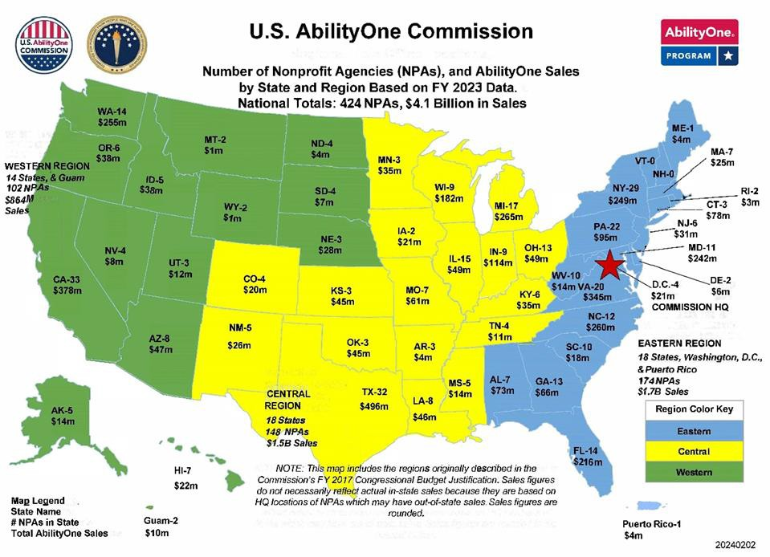

Appendix 3: AbilityOne by the Numbers

AbilityOne People and Numbers – FY 2023
AbilityOne employees who are blind or have significant disabilities | 36,600
AbilityOne wages paid | $731.9 million
Estimated Health and Welfare Fringe Benefits (in addition to wages) | $172.9 million
Average hourly wage | $17.58
Cost per job (Commission FY 2023 $13.124 million budget ÷ 36,600 jobs) | $359
Sales of products and services to Federal customers | $4.15 billion
Wounded, ill, or injured veterans working in AbilityOne direct labor jobs | 2,500
Outward placements from AbilityOne contracts | 1,610
Upward promotions within AbilityOne contracts | 2,476

Appendix 4: AbilityOne Employee Disability Characteristics
FY 2023
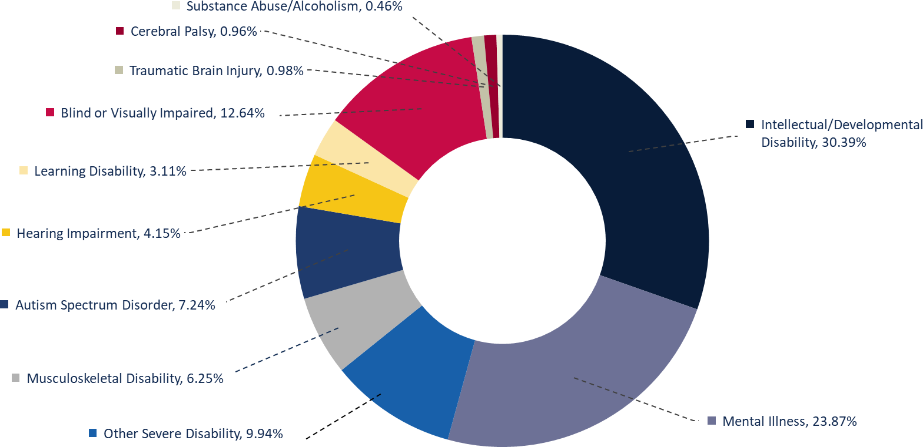

Appendix 5: Commission Meeting Dates and Public Engagement Topics
FY 2023 and FY 2024 quarterly public meeting dates and public engagement topics:

October 25, 2022: The scope, requirements, and metrics for the next generation of cooperative agreements between the Commission and its designated CNAs.

January 31, 2023: What is important to Federal agencies in terms of contractor performance – whether or not those contracts are awarded under the auspices of the AbilityOne Program – including perspectives on contract performance, quality assurance, and measurement of customer satisfaction.

April 13, 2023: Subcontracting and other partnerships with industry by or with AbilityOne employers.

July 13, 2023: The Notice of Proposed Rulemaking (NPRM) Supporting Competition in the AbilityOne Program (RIN 3037–AA14), published on March 13, 2023. The Commission particularly invited discussion on how the Commission can consider a nonprofit agency’s positive performance in improving employment opportunities for people who are blind or have significant disabilities, both within the AbilityOne workplace and placements outside the AbilityOne Program, in initial Procurement List additions and in any competitive process covered by the NPRM.

October 12, 2023: Modernizing the guidance for project development assignments and order allocations for nonprofit agencies participating in the AbilityOne Program.

January 25, 2024: Pathways from AbilityOne Program employment to Federal Government employment.

Additionally, the Commission held a virtual Town Hall on March 29, 2023, for stakeholders to provide feedback on three draft compliance policies issued in January 2023.

